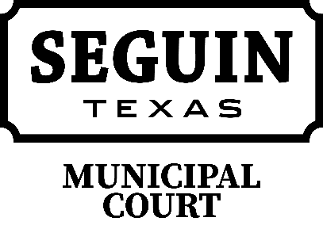

Seguin Municipal Court
Cordially invites you to attend the Tenth Annual

“Clerks and Judges Brunch”

Friday, May 18, 2018
9:00 a.m. - 10:00 a.m. - Meet and Greet Brunch
10:00 a.m. - 12:00 noon – "Las Vegas October 1, 2017 - Being There."
Presented by Deputy Chief Bruce Ure
Approved for 2 hrs of Clerk Certification Credit & 2 hours of Judicial Flex Time

12:00 noon – 2:00 PM - "Stop the Bleeding"
Presented by Sgt. Jeff Ferry
Approved for 2 hrs of Clerk Certiciation Credit
(Door prize winners will be announced after the session)

Location – Seguin City Coliseum, 950 S. Austin Street

This is an excellent opportunity for Judges and Clerks across our area to ask questions and gain feedback from other Courts. Please extend this invitation to your Prosecutors and Warrant Officers.

RSVP no later than May 4, 2018 –

RSVP to: Landra Solansky
830-401-2327
lsolansky@seguintexas.gov

