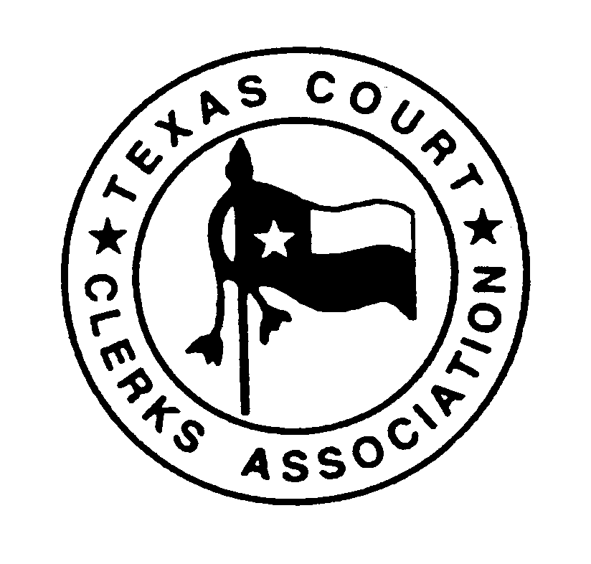
Texas Court Clerks Association
Merchandise Committee Chair
Last Updated January 02, 2019

T

The Merchandise Committee shall be responsible for merchandise sold at the Texas Court Clerks Annual Conference.

The Chairperson of the Merchandise Committee is appointed by the President at or immediately after the Annual Conference and will serve until the next Annual Conference, or until their respective successor is appointed.

The Chairperson of the Merchandise Committee is required to ensure that merchandise is ordered and available for sale at the Texas Court Clerks Annual Conference. The Chairperson is responsible for developing and maintaining a work schedule to guarantee the merchandise booth is properly manned during the designated times.

The Chairperson will be required to request a check in the amount of one hundred dollars ($100.00) from the Treasurer via electronic mail for the merchandise sales change fund. This request shall be made at least one month prior to the Annual Conference to allow the Treasurer sufficient notice to process the request. At the conclusion of the Conference, the Committee Chairperson is responsible for totaling the proceeds from the merchandise sales, inventorying the remaining merchandise and reporting the results to the Board at the Post Conference Board Meeting. The Chairperson will submit all sales receipts, merchandise proceeds and the one hundred dollars ($100.00) change fund to the Treasurer at the Post Conference Board Meeting.

It is the responsibility of the Merchandise Committee Chairperson to submit a request from the Texas Court Clerks Association Board of Directors for the exact amount of money that will be spent on new merchandise. The Chairperson may request reimbursement for expenses associated with purchasing merchandise by submitting a detailed receipt of the items that were purchased. Merchandise may be ordered online by contacting the TCCA President so the TCCA Credit Card can be used to secure the purchase. Purchases made in person should be made within the State of Texas and every effort should be made to make any purchase tax free using the tax-exempt certificate provided by the TCCA Treasurer.

As a Board Member, there are three Board Meetings and one Annual Business Meeting per year. The Pre-Conference Board Meeting, Annual Business Meeting and Post Conference Board Meeting are usually held in October. The Mid Year Board Meeting is usually held in the Spring. Failure to attend three of these four meetings beginning at the Post Conference Board Meeting for a twelve-month period shall constitute good cause for removal from office unless good cause is shown and approved by the Board of Directors. Expenses to attend the Mid Year Board meeting are paid by TCCA. Expenses for all other meetings are not reimbursable by TCCA. Budget restraints do not constitute “good cause” for absence from a TCCA Board Meeting. Committee Chairpersons who are not serving as an elected Board Member or Chapter President will not be required to attend all meetings. The Executive Board will review the agenda for the scheduled meeting and determine which Committee Chairs will be required to attend the meeting.
As the Committee Chairperson, you will be required to submit a report to the Board of Directors during the Mid Year Board Meeting and Pre-Conference Board Meeting. The report should include committee membership information, information regarding committee meetings and financial information (if applicable). The report submitted during the Pre-Conference Board Meeting will also be submitted to the general membership during the Annual Business Meeting.

Reports should be submitted to the TCCA Secretary no later than the date requested by the TCCA President. The Bylaws require the reports to be included on each of the conference drives and must be submitted timely so the TCCA Secretary has sufficient time to prepare the drives. In the event you are unable to submit your report as requested, you are responsible for contacting the Conference Host and confirming the number of printed copies you must bring to the meeting. A copy of the report must be sent to the TCCA Secretary via electronic mail for permanent storage.

Correspondence between Board Members and Committee Chairs may be done via electronic mail as long as the current listing of Board Members and Committee Chairs includes an email address. It is recommended that any correspondence sent using electronic mail require a return receipt. Correspondence must be mailed via postal service to any Board Member or Committee Chair who does not have an email address.

Board members will be asked to sign a Code of Ethics during the Post Conference Board meeting. The signed copy will be maintained by the TCCA Secretary. If the signed copy is scanned as a permanent document and stored electronically, the original may be destroyed. A new Code of Ethics will be signed by board members each year.

Job Descriptions will be distributed to all Board Members during the Post Conference Board meeting. Board members should notify the Secretary of any changes. Sample forms and letters should be sent to the TCCA Secretary via electronic mail for safekeeping.

It is the responsibility of the Committee Chair to follow the Records Retention Schedule for any records maintained while serving as Committee Chair.

Should a new appointment be made to serve as Committee Chair, it is the responsibility of the immediate past chairperson to deliver all records regarding the committee to the newly appointed chairperson as soon as possible following the appointment.

